Test Case: tc001_SPX_Dev5_Crear_Requisicion_Spot_Tipo_Cobro_CC
Step 1 - Enter username and password and click to button Enter : Credentials Entered
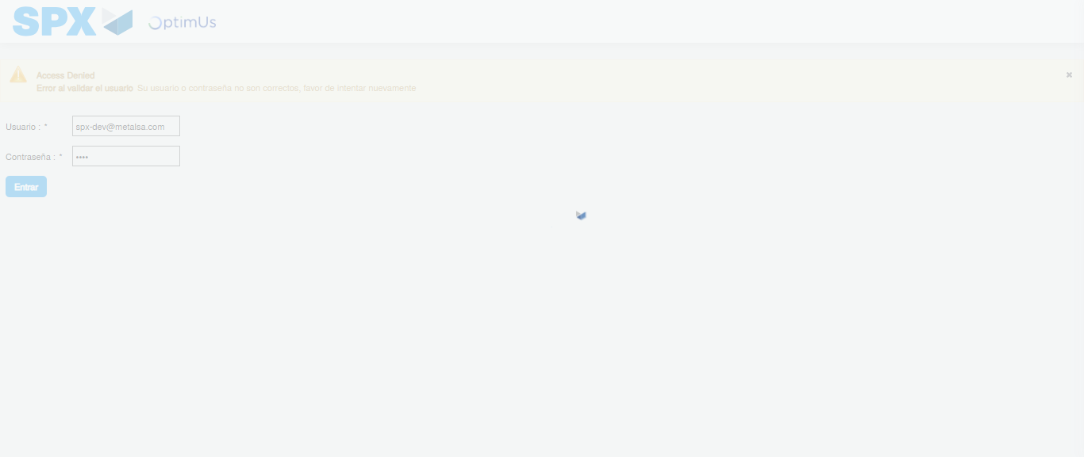Image file-name: QC_Testing-tc001_SPX_Dev5_Crear_Requisicion_Spot_Tipo_Cobro_CC-1783980500885

Step 2 - Select to UEN and Access to Spot Buy Requisitions : UEN Correctly selected and Correct access
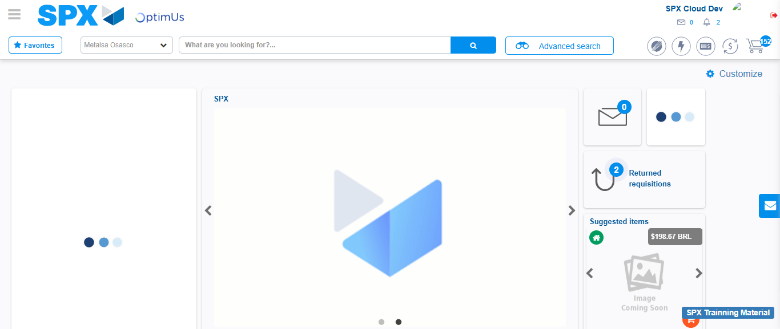Image file-name: QC_Testing-tc001_SPX_Dev5_Crear_Requisicion_Spot_Tipo_Cobro_CC-1783980526924

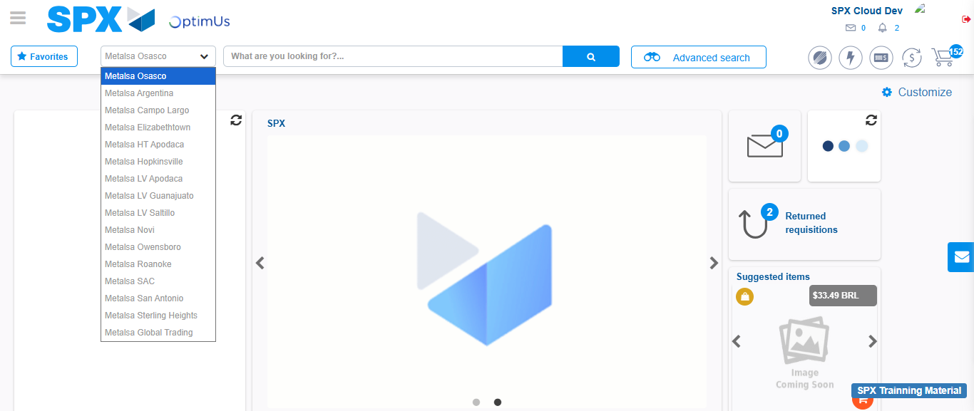Image file-name: QC_Testing-tc001_SPX_Dev5_Crear_Requisicion_Spot_Tipo_Cobro_CC-1783980529452

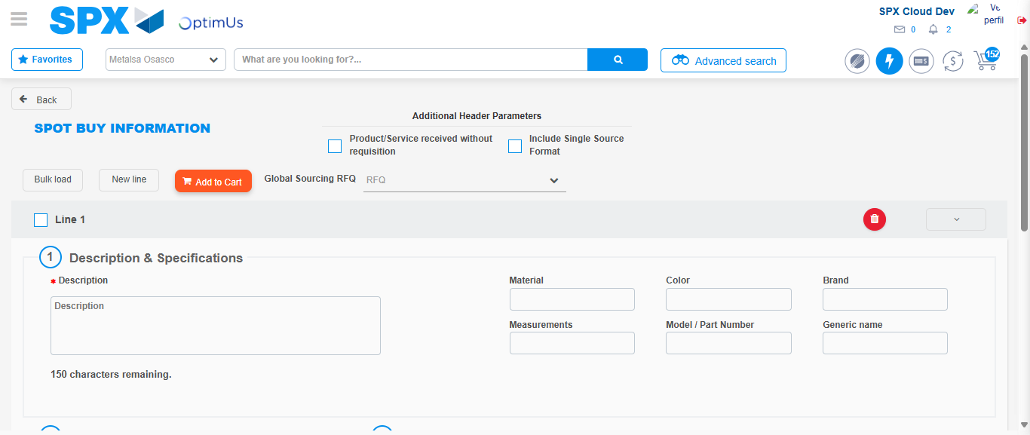Image file-name: QC_Testing-tc001_SPX_Dev5_Crear_Requisicion_Spot_Tipo_Cobro_CC-1783980549873

Step 3 - Data Capture Spot Buy Requisition : Data captured correctly
Image file-name: QC_Testing-tc001_SPX_Dev5_Crear_Requisicion_Spot_Tipo_Cobro_CC-1783980550104

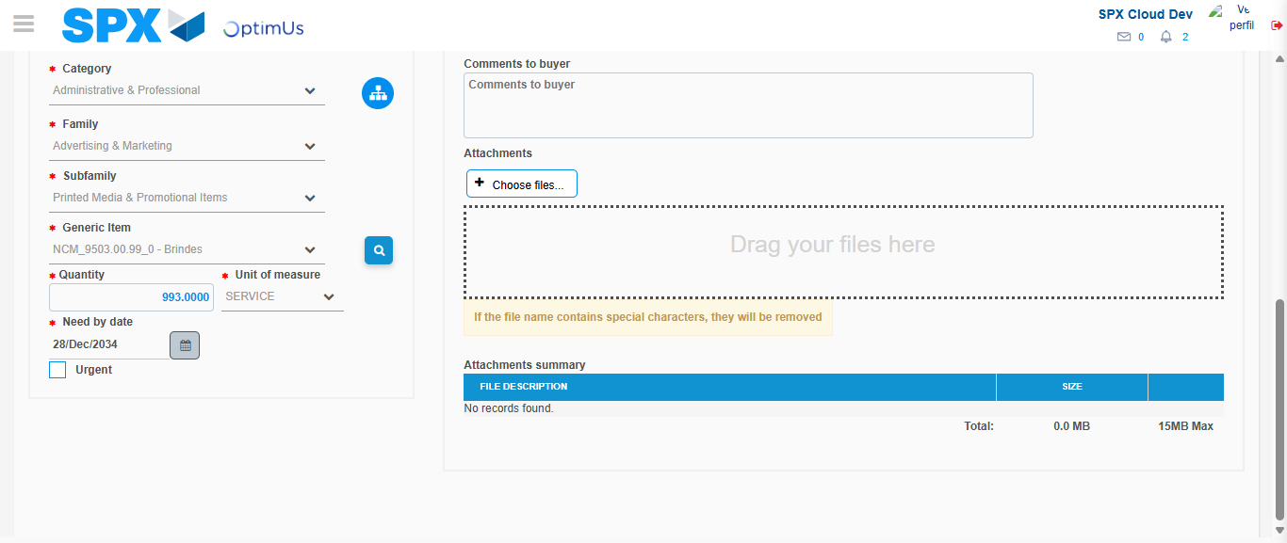Image file-name: QC_Testing-tc001_SPX_Dev5_Crear_Requisicion_Spot_Tipo_Cobro_CC-1783980561927

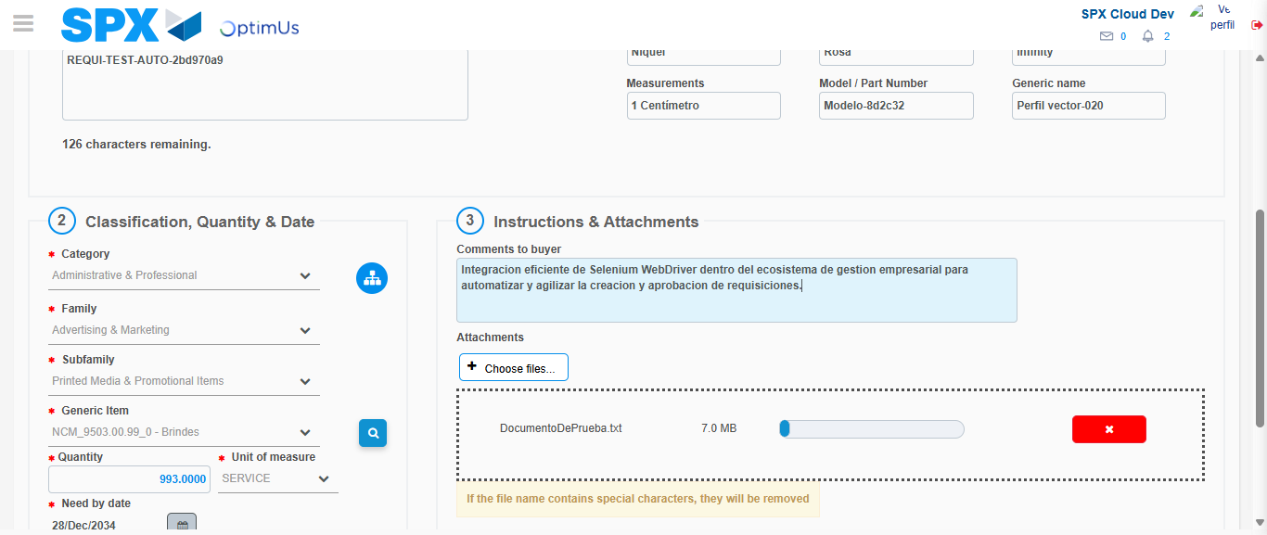Image file-name: QC_Testing-tc001_SPX_Dev5_Crear_Requisicion_Spot_Tipo_Cobro_CC-1783980562666

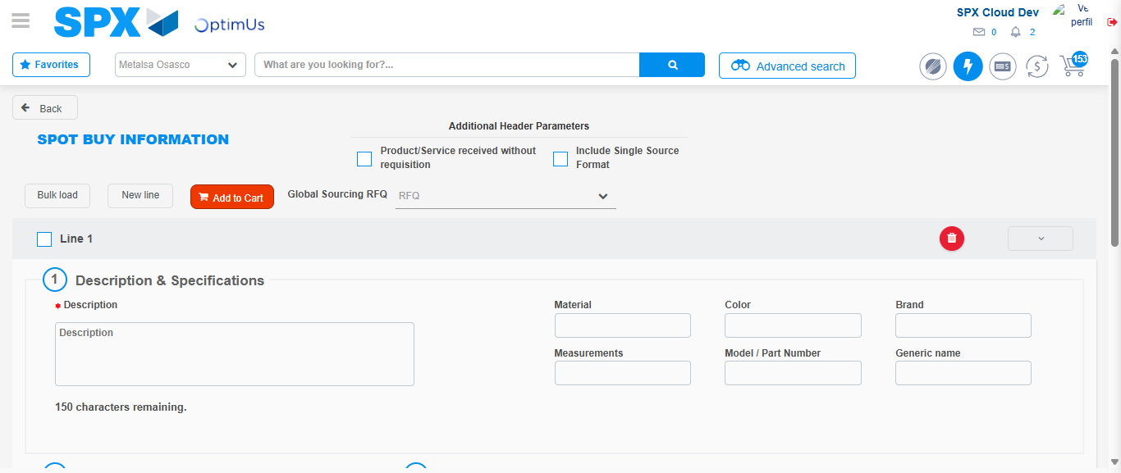Image file-name: QC_Testing-tc001_SPX_Dev5_Crear_Requisicion_Spot_Tipo_Cobro_CC-1783980572686

Step 7 - Return to Main Page SPX : Return to Main Page SPX
Image file-name: QC_Testing-tc001_SPX_Dev5_Crear_Requisicion_Spot_Tipo_Cobro_CC-1783980526924

Image file-name: QC_Testing-tc001_SPX_Dev5_Crear_Requisicion_Spot_Tipo_Cobro_CC-1783980529452

Image file-name: QC_Testing-tc001_SPX_Dev5_Crear_Requisicion_Spot_Tipo_Cobro_CC-1783980549873

Image file-name: QC_Testing-tc001_SPX_Dev5_Crear_Requisicion_Spot_Tipo_Cobro_CC-1783980574905

Image file-name: QC_Testing-tc001_SPX_Dev5_Crear_Requisicion_Spot_Tipo_Cobro_CC-1783980575048

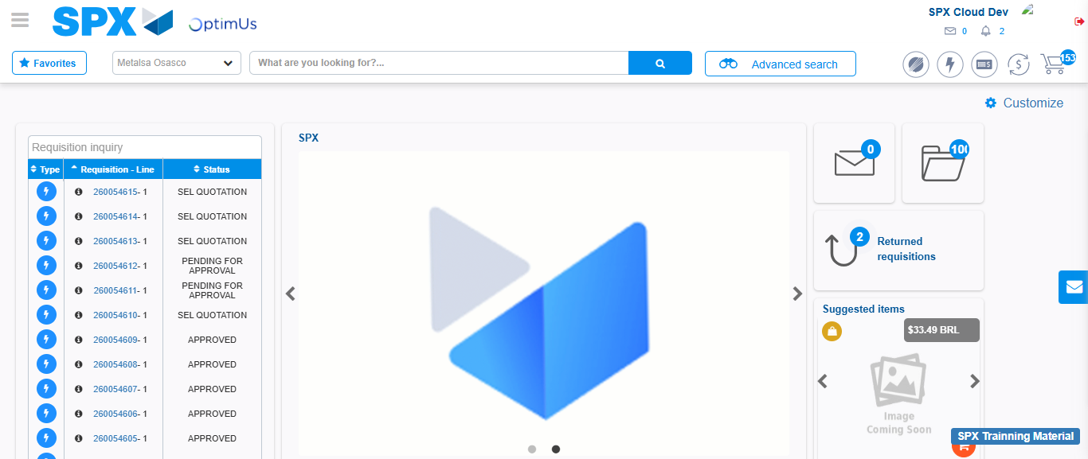Image file-name: QC_Testing-tc001_SPX_Dev5_Crear_Requisicion_Spot_Tipo_Cobro_CC-1783980596273

Step 8 - Log Out : Log Out SPX
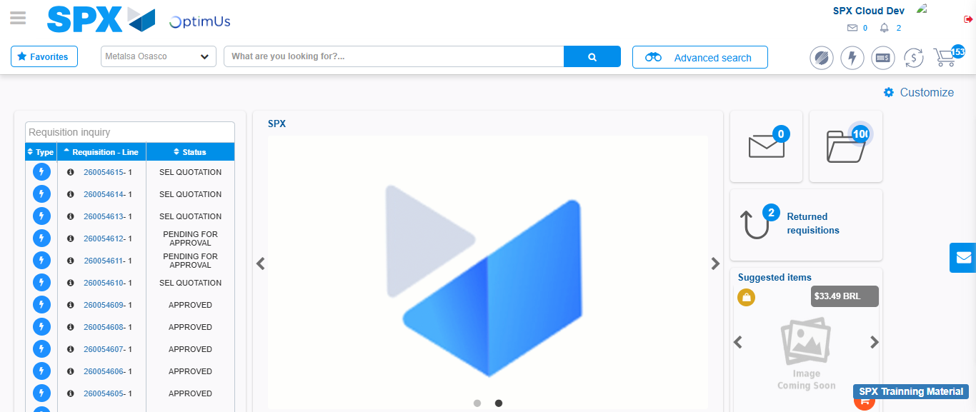Image file-name: QC_Testing-tc001_SPX_Dev5_Crear_Requisicion_Spot_Tipo_Cobro_CC-1783980596571

